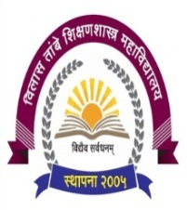

**Shri Gajanan Maharaj Shikshan Prasarak Mandal’s**

**Vilas Tambe women’s College of Education (B.ED.)**

**Dumbarwadi, Otur, Tal - Junnar, Dist - Pune - 412409**

**Links of various webinars videos organized by institute**

1. <https://www.youtube.com/watch?v=0oP8KbRFHoQ>

2. <https://www.youtube.com/watch?v=WfRd_lArY7Q&t=44s>

3. <https://www.youtube.com/watch?v=84mOkzBl38U&t=2218s>